**Lab 16: Using Kernel Debugging Commands with WinDbg**

**Course Name**: Malware Analysis and Reverse Engineering (IAM302)

**Student Name**: Nguyễn Trần Vinh – SE160258

**Instructor Name**: Mai Hoàng Đỉnh

**Lab Due Date**: 15/3/2023

**Purpose**

Practice using simple WinDbg commands.

**What You Need**

A Windows 10 machine with Livekd working, as prepared in the previous project. This project should work on Win 7 or any later version, but I only tested it on Windows 10

**Starting Configuration**

You should have Livekd running, which launched WinDbg, as you did at the end of the previous project

**Listing Modules with lm**

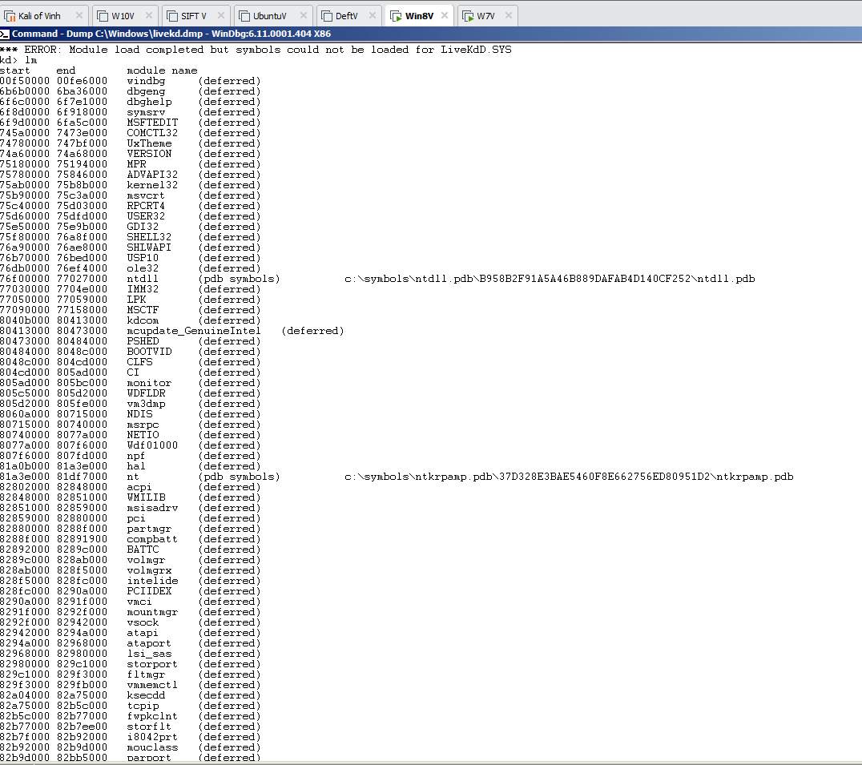 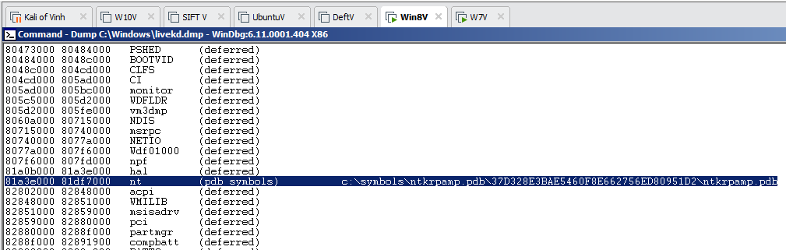

**Viewing Memory**

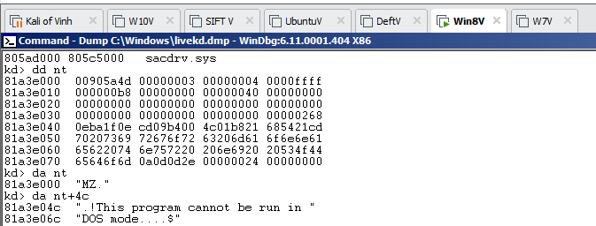

**Searching for Functions**

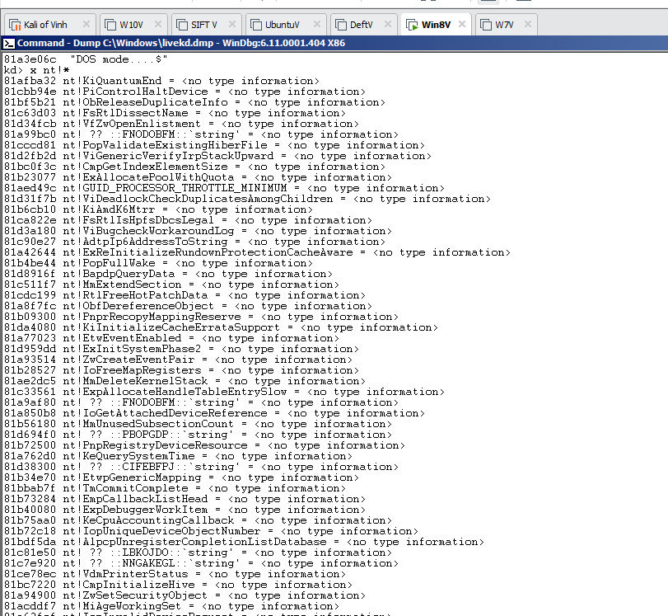

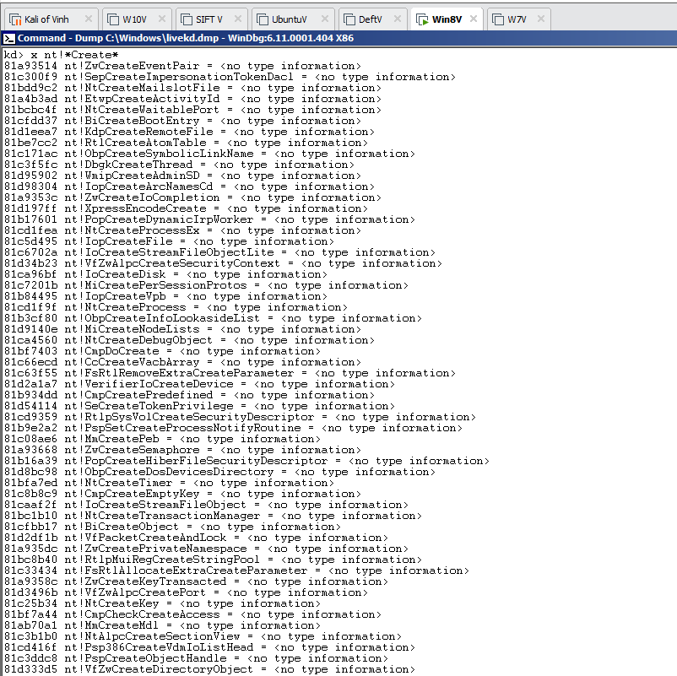

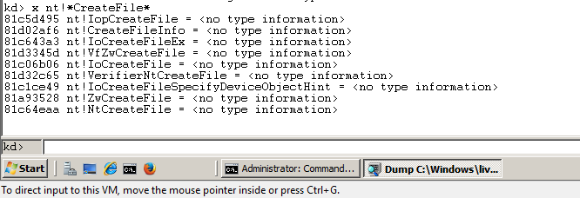

**Unassembling a Function**

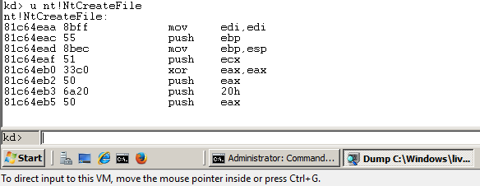

**View, Disassembly**

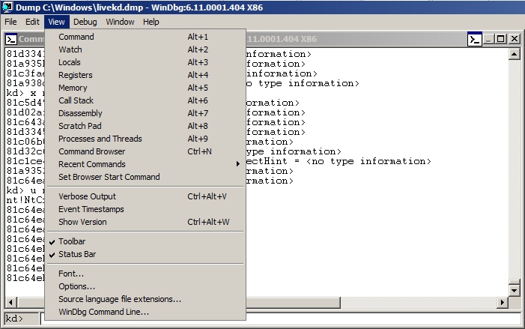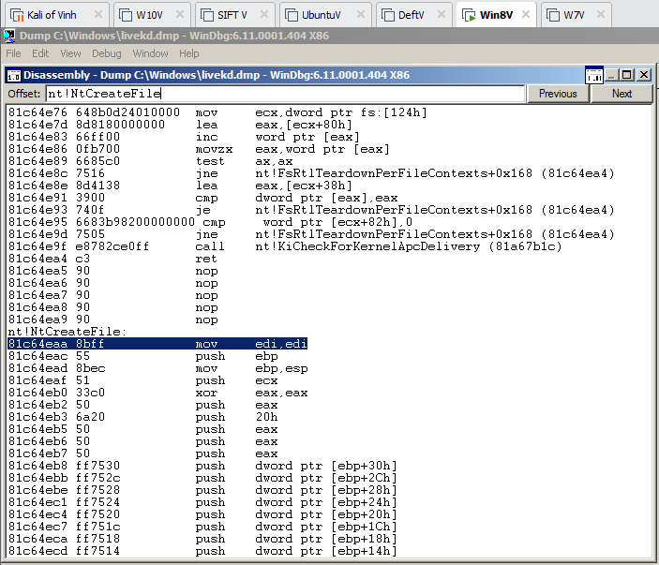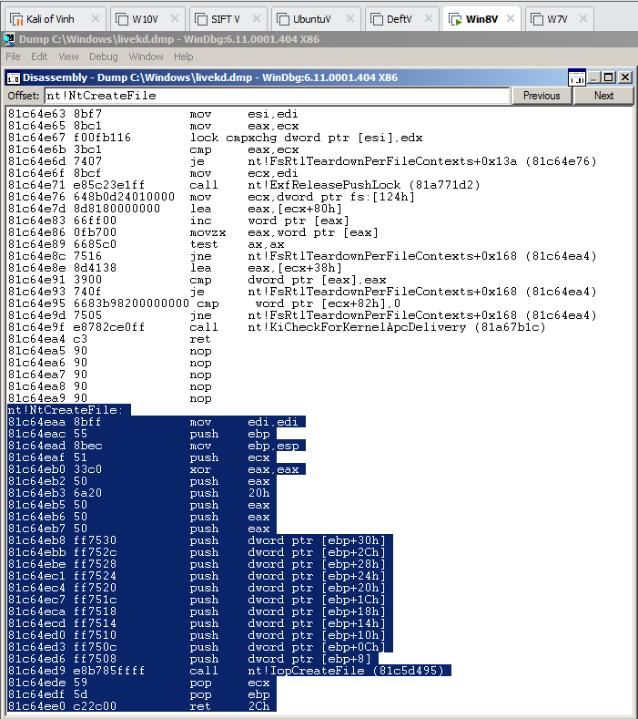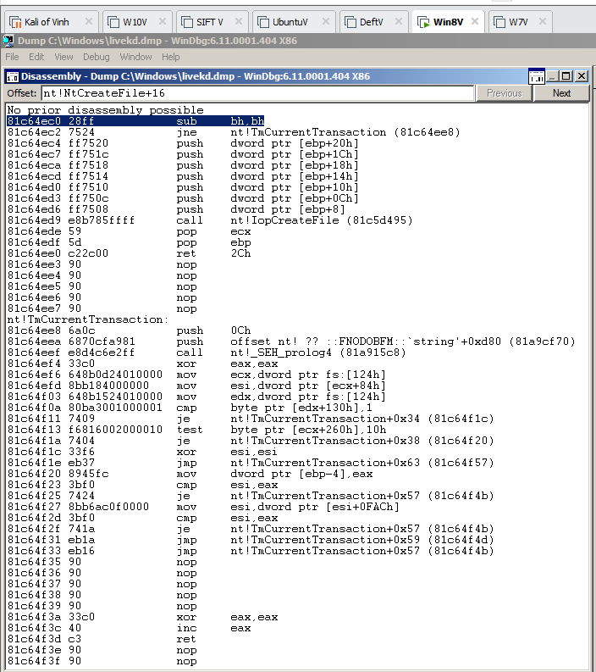

**Online Help**

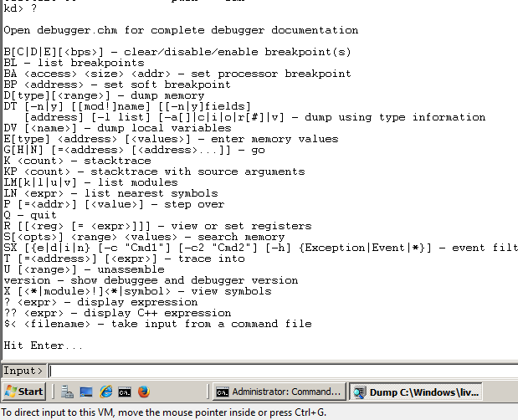

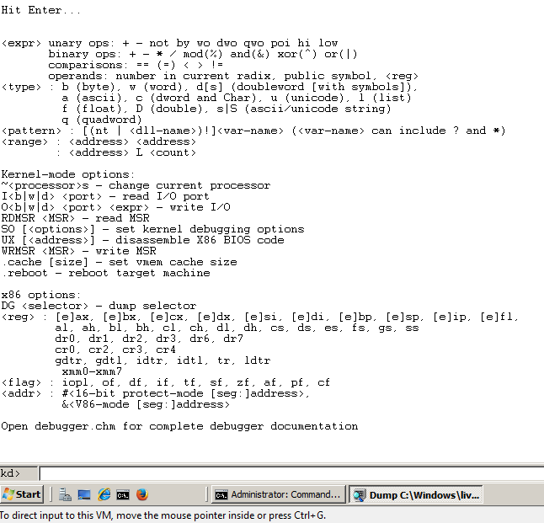

**Viewing Type Information for a Structure**

